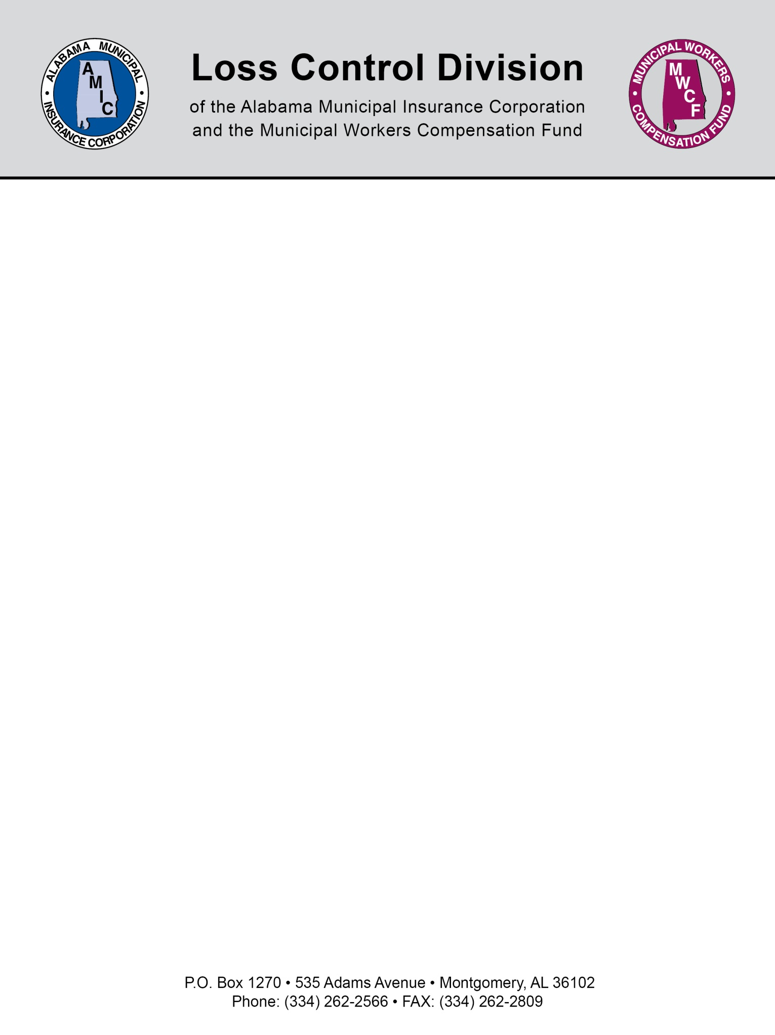

Chlorine Facts and Guidelines
Physical Properties
Color – greenish yellow
Odor – pungent, similar to laundry bleach. Detectable by smell at concentrations of 0.2 to 0.4 ppm.
Specific gravity – Approximately 2.5. This means gas chlorine is 2.5 times heavier than air, and will sink to the lowest level in a building or area.
Boiling point is -29.15 degrees F. Liquid chlorine that escapes from a cylinder or ton container will immediately convert to gas.
One volume of liquid chlorine converts to 460 volumes of gas.
Liquid chlorine that vaporizes on skin can reduce the temperature enough to cause frostbite.
Chlorine is not explosive or flammable, but can react violently with many substances.
Chlorine reacts with water to form hypochlorous and hydrochloric acids, with hypochlorous acid being the main disinfectant.
How Chlorine Exposure Affects Humans
Chlorine is a severe irritant. As noted above, when mixed with water (including moisture in mucous membranes, eyes and skin), it forms an acid. The primary route of exposure is through the eyes and respiratory system.
Exposure to chlorine has effects ranging from irritation to death, depending on the concentration and time of exposure.
A level of 10 ppm is considered Immediately Dangerous to Life and Health under the National Institute for Public Safety and Health (NIOSH).
At low levels for a short time, chlorine can cause eye irritation, coughing, sneezing, and throat irritation. At higher levels, labored breathing and vomiting may occur. Death can result from suffocation.
Dangerous Chlorine Reactions
Chlorine has the potential for violent or explosive reactions with certain substances. It is very important to separate chlorine from the following:
- Ammonia and ammonia compounds
- Hydrocarbons – oils, greases, solvents, even in small amounts.
Storage
Most plant operators store 150 pound cylinders or ton containers.
Always secure cylinders and ton containers to protect them from falling, rolling or being dropped.
Both cylinders and ton containers have fusible metal plugs that will melt when the temperature gets between 158 and 165 degrees F to relieve pressure. These pressure relief valves keep the containers from rupturing during a fire.
Chlorine may be stored indoors or outdoors, though shading from sunlight is recommended for outdoor storage. Storage areas should be away from HVAC intakes, as chlorine gas could be distributed throughout a building in case of a leak.

Indoor storage areas should have a ventilation fan located near the floor with a fresh air intake near the ceiling. The ventilation fan must be operated a switch that is weather proof and located outside the chlorine room entrance door. The fan should be turned on and allowed to run prior to entering the chlorine room.
Separate the chlorine storage area from incompatible materials, especially ammonia, sulfur dioxide, and hydrocarbons like fuels and oils.
The chlorine storage area should have a well-maintained chlorine gas detector installed, complete with alarm and call-out capability if a leak occurs when the plant is unmanned.
Unloading Chlorine Cylinders and Ton Containers
All employees receiving chlorine cylinders and containers must be properly trained.
Always use proper equipment to unload cylinders and ton containers. Chain cylinders to a hand truck, or move with a forklift if already secured in a storage rack.
- Make sure the protective valve housing is on securely
- Never lift a chlorine cylinder by its protective valve housing!
- Use a properly rated hoist or forklift to relocate ton containers. When using a hoist, remember that the total weight of the ton container is nearly 2 tons. A one-ton hoist is not sufficient for lifting a ton container.
- The hoist and cables must be in good operating condition. Have a professional inspect the hoist each year and repair or replace it when necessary.
- Never stand under a hoisted container. Stand to either side.
- Once the containers or cylinders are unloaded, secure them properly at the site. Always store cylinders in an upright position. Store ton containers with the two valves lined up vertically.

Chlorine Leak Response
NEVER respond to a chlorine leak unless you have been properly trained and have the necessary safety equipment—including a self-contained breathing apparatus and protective suit.
If your plant has its own HAZMAT Team, or provides the operators with the proper training and certification, follow your standard operating procedures.
Otherwise, call 9-1-1 or whatever agency is listed in your plant’s Emergency Response Plan.
To speed response and recovery, each treatment plant should have the appropriate Chlorine Institute Emergency Kit at the site:
- Kit A: for 100 or 150-pound cylinders
- Kit B: for ton containers
- Kit C: for tank cars and tank trucks
- Cylinder containment vessels: for 100 or 150-pound cylinders
Whether a chlorine leak is handled in-house or not, your Emergency Response Plan should detail the exact procedure. Most importantly, practice, practice and practice the procedure. Finding the Emergency Response Plan and reading it is not a good option in the middle of a chlorine gas leak.
Connecting and Disconnecting Chlorine Cylinders and Containers
Changing cylinders or containers is one of the most likely opportunities for exposure to chlorine. It is extremely important to make sure all operators are thoroughly trained before attempting the task.
Make sure the appropriate personal protective equipment is available and worn during the procedure.
  - Self contained breathing apparatus with full face mask
  - Gloves
  - Hard hat
  - Safety shoes
  - Long sleeved shirts
  - Pants
  - Clothing and gloves should be free of oil or grease.

Security
The events of 9/11 made treatment plant security all the more important.
Control access to chlorine cylinders and containers with gates, locked buildings and other barriers. Provide bullet-proof shields for containers that are not indoors.
If funding allows, use electronic gates and doors with access badges that record the comings and goings at the plant. If not, ensure all visitors sign in and show photo identification.
Include security requirements in your specifications when taking bids for chlorine or other hazardous chemicals. These requirements may include training for the company’s staff, a written security plan, a list of delivery drivers with record checks completed, and more.

NOTE: This document is not intended to be legal advice. It does not identify all the issues surrounding the particular topic. Public agencies are encouraged to review their procedures with an expert or an attorney who is knowledgeable about the topic. Reliance on this information is at the sole risk of the user.
Revised 10/2013

